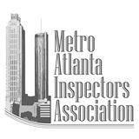Be Prepared to help in a disaster.
Come join us for an all-day Disaster Assessment training course.
- Wednesday February 19, 2020; Registration 7:30 am 8:00 am to 4:30 pm
- Gwinnett Justice & Administration Center
75 Langley Drive,
Lawrenceville, GA 30046
Second floor Conference Room C
- Cost $120.00 (fee includes training material and ATC handbook 20-1 and 45)
- 1 hour lunch will be on your own
- No door registration will be available, you must pre-register. Register at:
- https://www.aiaga.org/events/disaster-response-training-5/
Anyone is invited to attend, but in order to be registered with California Emergency Management Agency (CalEMA) Safety Assessment Program (SAP) you must be A Building Official or A Building Inspector (see full list on back):
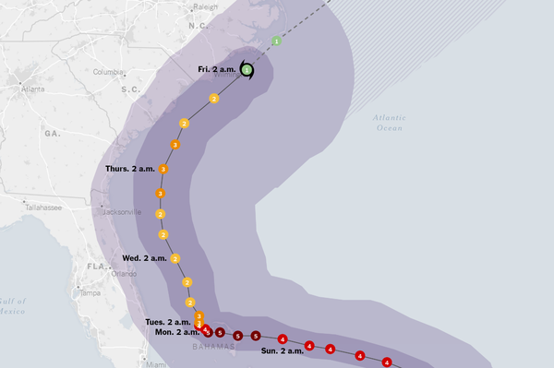

Cal OES Safety Assessment Program Approved Licenses & Certifications
Card Designation Prof. License/Cert Agency
Architect, Any state
Civil Engineer Civil Engineer, Any state
Structural Engineer Structural Engineer, Any state
Geotechnical Engineer Geotechnical Engineer, Any state
Engineering Geologist Engineering Geologist, Any state
Building Inspector DSA School Construction CA DGS/ DSA Inspector, Classes 1 & 2
Building Inspector OSHPD Hospital Inspector CA OSHPD Class A
Building Inspector Registered Const. Insp. Div. II ACIA
Building Inspector Building Inspector ICC
Building Inspector Combination Inspector ICC
Building Inspector Combination Dwelling Inspector ICC
Building Inspector Commercial Building Inspector ICC
Building Inspector Residential Building Inspector ICC
Building Inspector Residential Combination Inspector ICC
Building Inspector Building Plans Examiner ICC
Building Inspector Combination Plans Examiner ICC
Building Inspector Building Code Official ICC
Building Inspector Certified Building Official ICC
Building Inspector Master Code Professional ICC
Public Works Inspector Registered Const. Insp. Div. IV ACIA
Public Works Inspector Construction Inspector City of Los Angeles

